This dataset includes individual heart health status indicators. It contains characteristics including age, gender, cholesterol, blood pressure, and whether or not the person has had a heart attack. The dataset is useful for evaluating the risk factors linked to heart disease and for trend analysis about cardiovascular health. Personalized therapies for heart disease prevention and management can be developed by researchers and healthcare professionals using this data to find patterns and create predictive models.

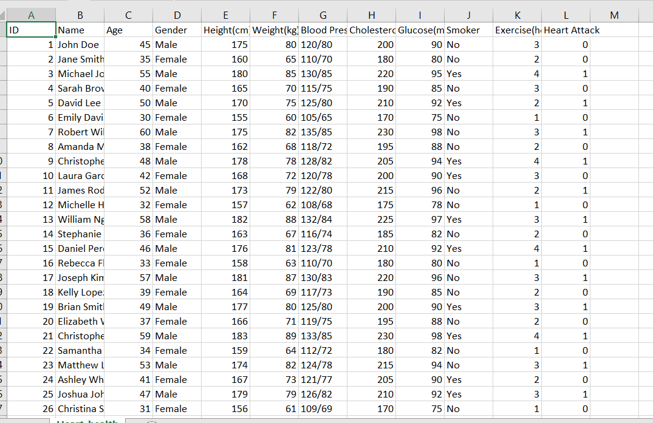

We found this from Kaggle data set.